
Physics and Astronomy
University of Missouri Fall 2023

Communiqué
News From the Chair

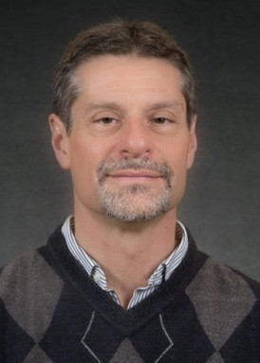
Dear Alumni, Colleagues and Friends,
Greetings from the Department of Physics and Astronomy. We had an eventful year and I hope to bring you up to speed in this newsletter, including the many accomplishments of our students and faculty.
We are pleased to welcome our new assistant professor, Dr. Keith Cassidy, to our department. Dr. Cassidy received his PhD from the University of Illinois at Champaign-Urbana and then did postdoctoral work at the University of Oxford before joining us in August. Dr. Cassidy’s research in biophysics utilizes multi-
scale computer simulations to investigate the mechanisms of bacterial chemo-sensing. Dr. Cassidy was hired via the campus-wide electron microscopy faculty search that was led by our department.
I am heartbroken to report that Curators’ Distinguished Teaching Professor and Associate Department Chair Dorina Kosztin passed away January 5, 2023. She was a beloved friend and colleague to everyone in the department and her untimely passing made 2023 a very difficult year for all of us. Prof. Kosztin was an outstanding teacher who was cherished by her students. She was also a leader among teachers and Dr. Kosztin had many awards for her accomplishments in teaching and mentoring, including the William T. Kemper Fellowship, the President’s Award for Innovative Teaching, and just before her passing, Prof. Kosztin was recognized at Curators’ Distinguished Teaching Professor. As she taught our introductory calculus-based physics courses over the past 20 years, she touched the lives of over 10,000 students. In her honor, the large lecture hall in room 126 has been named “The Dr. Dorina Kosztin Memorial Lecture Hall”.
In student news, the Department graduated 19 BS degrees, 2 MS degrees and 7 PhDs in academic year 2022-23. Our student organizations, the Physics and Astronomy Graduate Student Association (PAGSA) and the Society of Physics Students (SPS), continue to hold events throughout the year.
Mizzou Women in Physics and Astronomy (MOWiPA) is a newly formed organization that is intended to connect and support female undergraduate and graduate students as well as faculty. Two of our undergraduate students, Jayden Francois and Donovan Flagg, were awarded the nationally sponsored TEAM-UP Together Scholarships for the 2023-24 academic year.
In faculty news, Yicheng Guo, Assistant Professor in astrophysics, received tenure and promotion to Associate Professor this year. Curators’ Distinguished Professor David Singh, who was previously at Oak Ridge National Laboratory and joined our department in 2015, retired in early 2023. Prof. Singh is well-known nationally/internationally for his many important contributions to theoretical condensed matter physics, particularly using density-functional theory to understand
Continued on page 8… 1

In Remembrance
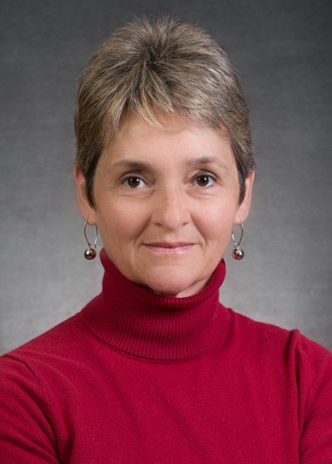
Long time department professor and associate chair Curators’ Distinguished Teaching Professor Dr. Dorina Kosztin passed away suddenly on January 5, 2023. In her 21 years at MU Dorina became a critical and influential member of our department. Her loss is deeply felt by all of us as both a colleague and a friend.
After growing up and attending college in Romania, where she met (in high school) and married Ioan Kosztin, Dorina entered the PhD program in physics at the University of Illinois. In 2001 Dorina, along with Ioan, became a faculty member in the Department of Physics and Astronomy at the University of Missouri, where she worked until her untimely
passing. She was a beloved colleague who also served for many years as the Associate
Chair of the department. She was an admired teacher who impacted the lives of many thousands of students. In 2005 she received the Provost Junior Faculty Teaching Award, which was only the beginning of the more than a dozen teaching awards she received. In 2008 Professor Kosztin received the prestigious William T. Kemper Award for Excellence in Teaching, and in 2014 she received the Science Teachers of Missouri Distinguished Service Award, and the UM System President’s Award for Innovative Teaching. Most recently, in 2022, Professor Kosztin was recognized as Curators’ Distinguished Teaching Professor, the highest academic rank awarded by the University of Missouri.
Dorina always had a positive outlook to provide in any situation and was a source of knowledge and assistance to every student and faculty member in the department. She was an exceptional individual who will long be missed. One of our large lecture halls has been named in her honor, recognized by a plaque placed in the hallway where students and faculty pass by daily.
More of her obituary can be found at https://www.dignitymemorial.com/obituaries/columbia-mo/dorina-kosztin-11095828.
A fund has been set up in her memory that will support the endeavors of physics students at the University of Missouri.
Donations can be made:
- Online at https://giving.missouri.edu/dorina-kosztin
- By phone: 573-884-7709
- By check made out to: University of Missouri, with a memo to, Physics Development Gifts Fund – Memory of Prof. Dorina Kosztin.
Mailing address: Mizzou Advancement, 407 Reynolds Alumni Center, Columbia, MO
65211.

Endowment

The department recently received a generous endowment of
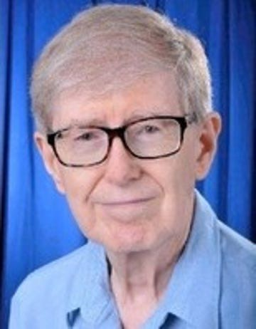
$600,000 bequeathed from the estate of Dr. Orville Lee Smith to create a fellowship to support a physics PhD graduate student, to be named the “Orville Lee Smith Fellowship in Graduate Physics”.
Dr. Smith received his PhD in Physics from our department in 1962. Following graduation, he worked at Oak Ridge National Laboratory. His work there included serving as senior research and development scientist in nuclear power plant design and other areas. Dr. Smith was also a part time Associate Professor of Nuclear Physics at the University of Tennessee, Knoxville.
Dr. Smith’s generosity will benefit many students in the years to come enabling them to pursue their own areas of physics research

Welcome

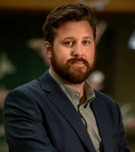
The department welcomes Dr. Keith Cassidy as a new assistant professor. Professor Cassidy’s research specializes in computational biochemistry and biophysics. His lab at MU will utilize a combination of molecular simulation methods to analyze the structure and function of diverse biomolecular systems. He is especially interested in the application of such techniques to study bacterial chemosensory arrays, the remarkable protein complexes mediating the sensory signal processing underlying much of bacterial motility.
Prior to joining our department, Professor Cassidy was a postdoctoral researcher at the University of Oxford and the Diamond Light Source in England. He received his Ph.D. in Physics from the University of Illinois Urbana-Champaign and B.S. in Physics from the University of Arkansas.

Faculty News & Recogni:on

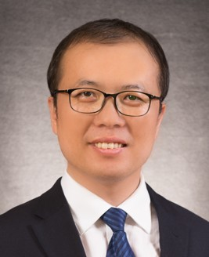
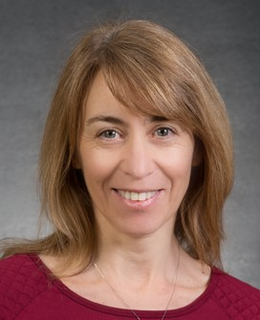
Guang Bian, was selected as a 2023 Gordon and Betty Moore Foundation Experimental Physics Investigator. The award includes a five-year, $1.25 million grant for Bian to pursue transformative research during a critical time in his career directly following the attainment of tenure. (for more information check out showme.missouri.edu, search “Guang Bian”

Silvia Bompadre was appointed Associate Department Chair, adding to her duties as Director of Undergraduate Studies.

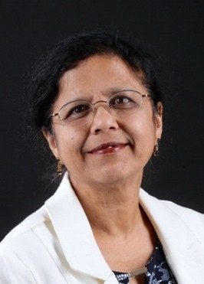
Shubhra Gangopadhyay was named as one of 2022 Fellows of the American Association for the Advancement of Science
(AAAS). Gangopadhyay is being recognized for her “distinguished contributions in bioengineering for the development of plasmonic gratings and nanoelectronic device-based biosensor systems for ultrasensitive detection of biomarkers.”

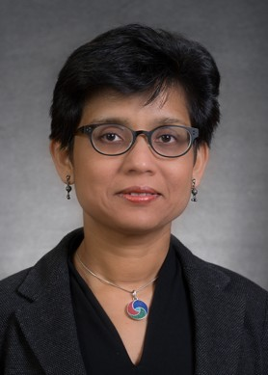
Suchi Guha was awarded a research grant by the National Science Foundation entitled “Textured Organic Ferroelectric-Based Transistors as Neuromorphic Devices” with CoPIs: Gavin King and Shubhra Gangopadhyay. This grant is for three years, starting September 2023, for an amount of $ 418,604. The project focusses on developing new device architectures for highly efficient and low- power consuming organic transistors for investigating both electrical and photonic synapses. She is also a CoPI (with PI: Prof.
Gavin King) on a research grant by the National Science Foundation entitled “Ice Lithography - A Novel Nanomanufacturing Process.”
This grant is for three years, starting July 2023, for over $510,565.
Suchi was invited to give a keynote presentation at the NanoAfrica Conference (October 2022) in Cape Town, South Africa. She gave other invited presentations at the Fall

meeting of the American Chemical Society in San Francisco (August 2023) and the SPIE Optics+Photonics meeting in San Diego (August 2023). Two graduate students working with her, Payal Bhattacharya and John Barron, successfully defended and obtained their PhDs in May 2023. Payal now works as a thin film engineer at MKS Instruments Inc. (California) and John is an optical thin film engineer at Coherent Inc. (New Jersey). The ultrafast laser laboratory that Suchi and Ping Yu started in 2020 is now fully functional and resulting in new research and publications.

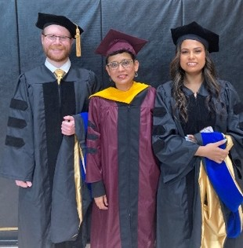
John Barron, Prof. Guha, Payal Bha1acharya

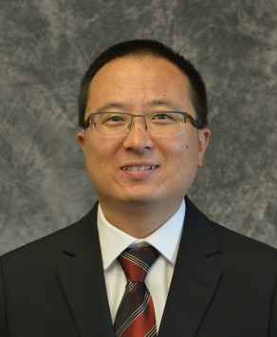
Yicheng Guo was promoted to associate professor with tenure in 2023. His research group continues growing. A proposal led by Dr. Guo ("Analyzing Giant Clumps in JWST Images of Star-Forming Galaxies to Constrain Feedback") has been approved by NASA/Space Telescope Science Institute to use James Webb Space Telescope's archived infrared data to study the sub- structures of distant galaxies. The results will be used to test the state-of-the- art models of galaxy formation as well as to train machine learning algorithms to detect galactic structures. In the short-wavelength regime, graduate
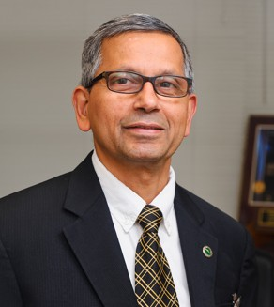
student Alec Martin of Guo's group just published a paper in a top astronomy journal, ApJ, to study galactic clumps in ultraviolet light.

Kattesh Katti was elected to the 2023 College of Fellows of the American Institute for Medical and Biological Engineering (AIMBE).

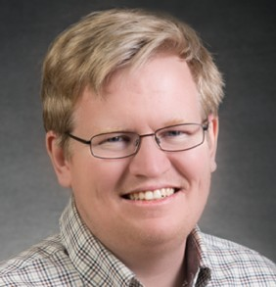
Gavin King- In the fall of 2022, King laboratory celebrated the PhD defense of Katherine (Katie) Schaefer. But lucky for the lab, they did not have to say goodbye (yet)! Dr. Schaefer decided to stay in the lab on upon graduating and is currently a Research Excellence Postdoctoral Program (REP) Research Associate. Her research is focused on a pore-forming peptide which is generated by a common fungus, Candida albicans. This is the first peptide toxin identified in any human fungal pathogen. Dr. Schaefer has used AFM
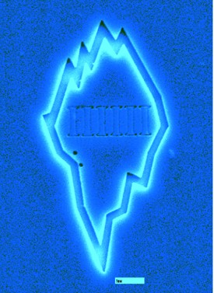
imaging, transmission electron microscopy, and other techniques to study the molecular mechanism that CL uses to disrupt membranes and has recently published work on this topic in a high-profile biological journal.
In addition, the King laboratory has an ongoing NSF-funded project in collaboration with Ioan Kosztin in our Department. This work is focused on fundamental aspects of protein-lipid interactions and takes a combined experimental-theoretical approach. In summer of 2023 the King lab received a new NSF grant in collaboration with Suchi Guha in our department and Bernadette Broderick from MU Chemistry. This project is a seed grant to develop a new high precision patterning technique known as “Ice Lithography”. The group had some fun designing and
fabricating a logo for the nascent MU Ice Lithography effort (see figure). Note the six columns on
the interior of the iceberg; the scale bar is 1 micron. 5

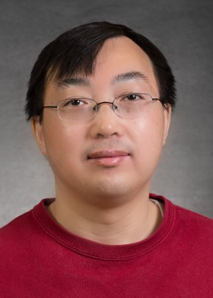
Per Nature’s invitation, Aigen Li and Xuejuan Yang, his former postdoc at MU and now professor at Xiangtan University, published an invited News & Views article entitled “Interstellar dust revealed by light from cosmic dawn” in Nature (X.J. Yang & A. Li, 2023, Nature, vol. 621, pp. 260-262). In this article, they discussed the nature and origin of aromatic dust at the cosmic dawn, when the Universe was only 800 million years old.

Aigen Li was awarded in 2022 a NASA Astrophysics Research and Analysis grant of $231,212 for studying polycyclic aromatic hydrocarbon
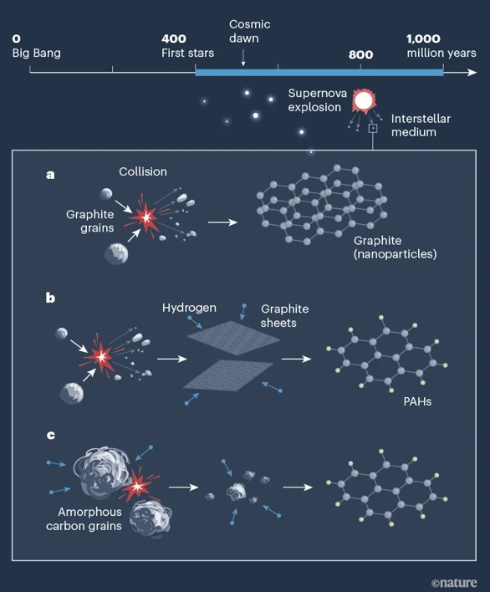
molecules in planet-forming disks orbiting young stars. He is currently also leading a James Webb Space Telescope (JWST) project for studying aromatic and aliphatic organic matter in the Universe. Selected in 2023 in JWST’s Cycle 2 competition, this project is expected to bring in $178,000 exclusively to PI Aigen Li at MU. Aigen Li is also leading a JWST project to study polycyclic aromatic hydrocarbon molecules in M82, a prototypical starburst galaxy. Selected in 2021 in its Cycle 1 competition, this project brought in $148,007 in 2022, among which $109,237 went to PI Aigen Li in MU and $38,770 went to Co-I Jianwei Lyu in the University of Arizona. Aigen Li also participates as a Co-I in a JWST project of over 20 hours and a Hubble Space
Telescope (HST) project of over 20 orbits for studying dust in low-density interstellar clouds. The JWST collaboration brought in $58,073 to MU in 2022, while

the HST collaboration brought in $39,555 to MU in 2023. Unlike JWST which operates in a halo orbit, circling around a point in space known as the Sun– Earth L2 Lagrange point, approximately 1.5M km
The nature and origin of aroma0c dust at the cosmic
dawn, when the Universe was only about 6% of its current age (X.J. Yang & A. Li, 2023, Nature, 621, 260-262).

(930,000 miles) beyond Earth's orbit around the Sun, HST is in a low-Earth orbit at an altitude of approximately 540 km (340 miles) above Earth and it takes about 95 minutes to complete one orbit.

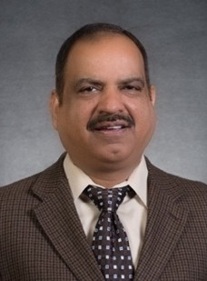
During Spring 2023, Sashi Satpathy spent a one-semester Research Leave under the Fulbright Fellowship program at the Indian Institute of Technology Madras in Chennai, India to continue an ongoing collaboration. Graduate students Pratik Sahu and Tapesh Gautam also joined in the collaboration.
Main research included 2D quantum materials, strong spin-orbit coupled solids, and the skyrmion state in solids.

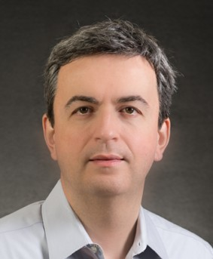
Carsten Ullrich was awarded a research grant by the US Department of Energy entitled "Time-dependent density-functional approaches for noncollinear spin dynamics." The grant is for three years, starting July 2023, and over the amount of $428,829. This funding will be used to develop theoretical and computational methods to study spin-dependent nonequilibrium phenomena in quantum materials. The grant supports one postdoc, Dr. Daniel Hill, and a graduate student.
Carsten Ullrich was a co-organizer of a School and Workshop on Time- dependent density-functional methods for excited states and dynamics. The
conference took place from June 29 to July 8, 2023, at Rutgers University, Newark, and was
attended by over 80 participants. To support the event, Dr. Ullrich secured $10,000 financial support from the National Science Foundation. A memorable aspect of the conference was the birthday celebration of three of the most outstanding researchers in the field of Density Functional Theory (DFT): Kieron Burke (UC Irvine), Hardy Gross (Hebrew University, Jerusalem) and John Perdew (Tulane University). Perdew and Burke are known as the "P" and "B" of the famous PBE functional published in 1996, which is one of the most highly cited scientific papers. He was also named a Curators’ Distinguished Professor in September.

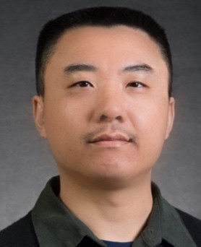
Haojing Yan has been leading his group working on a few large projects, and the most exciting ones are to make use of the gorgeous data from the James Webb Space Telescope (JWST). This year, he has led two new papers related to the JWST, one of which is on the first use of this giant space telescope to study transient phenomena in the universe. This work will be featured by NASA’s Space Science Institute (STScI, in charge of the JWST science operation) through a press release scheduled in October. A related, but different JWST program led by Haojing to study transients was recently
awarded 10.8 hours of Director’s Discretionary Time (DDT) and will be carried out in October.
Along a different line of research, Haojing will soon submit (again in October) yet another new paper, which builds upon his work from last year on the very early galaxies and will bring this study to a new level. Haojing was featured in an article in Show Me Mizzou regarding his work with the James Webb Space Telescope. He had been waiting to work with data from the telescope since he was guaranteed observation time with it 21 years ago as a graduate student on a research team. (for more news, check out showme.missouri.edu, search “Back to the Beginning”)

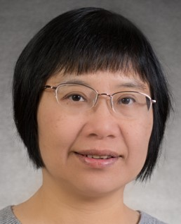
Xiaoqin Zou was named as one of 2022 Fellows of the American Association for the Advancement of Science (AAAS). Zou is being recognized for her “distinguished contributions to the field of computational and theoretical biophysics, particularly for developing novel physics-based algorithms for modeling protein interactions with applications to structure-based drug design.”

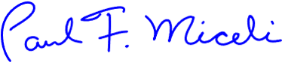
(News from the Chair, Cont. from page 1)
thermoelectric materials and other novel material systems. The department is grateful to be engaging in three faculty searches this year. We are searching for two tenure-track junior faculty, one as Assistant Professor in Astronomy/Astrophysics and the other being the George H. Vineyard Assistant Professor of Theoretical Condensed-Matter Physics. We also have a search for a non- tenure track assistant teaching professor who will support our service teaching mission of the large- enrollment introductory physics courses.
In staff news, Gay Sturguess retired in July. We celebrated her 20 years of service in our department office with a luncheon in the spring. Gay’s operational knowledge and the excellent support that she gave us over the years will be sorely missed. We also welcome Ray Armstead who recently joined our office staff.
Over the past year the department witnessed many important accomplishments in research. Our astrophysics faculty have had outstanding success using NASA’s recently launched James Webb Space Telescope (JWST). Prof. Aigen Li and Prof. Yicheng Guo received observation time on this much-coveted space telescope. And Prof. Haojing Yan’s research reported the first z≈11–20 galaxies from JWST—galaxies that were formed much earlier after the big bang than expected. Dr. Yan participated in an American Astronomical Society news conference in January 2023 where their results were publicly announced. Prof. Gavin King demonstrated ice lithography patterning at less than 10 nm resolution -- a novel capability with the potential to revolutionize patterning of bio/inorganic materials at the nanoscale. This fall, Prof. King and Prof. Suchi Guha received an NSF Advanced Manufacturing grant to develop ice lithography. Prof. Guang Bian received the highly prestigious Gordon and Betty Moore Foundation grant ($1.25M) for his work on quantum materials.
The department greatly appreciates our alumni who continue to support our students and our mission. At our 2023 Physics Leaders’ Meeting, Oct. 13-14, alumni gathered with faculty and students to catch up on the latest in the department. Six students gave research presentation at the meeting and a banquet was held on Friday evening of the meeting. Our alumni continue to support endowments that play a critical role in supporting our students, particularly our graduate students on teaching assistantships who do not otherwise have summer support. We are excited to announce that this past fall we received a new endowment from the estate of Dr. Orville Lee Smith (PhD 1962). This endowment will support the annual stipend of one graduate student.
The department hosted several noteworthy events over the past year. A Physics Open House was held in April, organized by Prof. Yun Zhang with the help of numerous graduate and undergraduate students, as well as ten high school students. It is estimated that over 250 children and their families came out to enjoy this event. Prof. Carlos Wexler organized the American Physical Society Prairie section meeting on our campus, Dec. 1- 2. It was a regional conference that was attended by over 120 students and faculty from universities in the Midwest. A plenary talk on Nov. 30th by Prof. Edward Kolb from the University of Chicago on “The Quantum and the Cosmos” was a kickoff event open to the public. Over 250 people are estimated to have attended from the University and Columbia communities. The department also continues to host well-attended viewings for the public, weather permitting, at our Laws Observatory every Wednesday night.
On behalf of the Department of Physics and Astronomy, I wish everyone the very best for 2024.

Undergraduate Degrees
Our Graduates

Departmental Honors requires
Fall 2022 BA
Sebastian Boyd
BS
Tomisin Peter Ashaolu David Bogar Miles Gray
Brandon Hodges
Adam Scantlin, emphasis in Astronomy
Drake Sivils, emphasis in Materials Science

Spring 2023 BS
Nicholas Childers
Jude Huck-Reymond, Cum Laude
James McMillen, Summa Cum Laude, emphasis in Astronomy
Andrew Olds, emphasis in Astronomy
Winston Penrod, Cum Laude, emphasis in Astronomy
Anthony Puleo, emphasis in Astronomy
Alli Salamone, Summa Cum Laude
Troy Schneider, Cum Laude
Justin Shotton, Summa Cum Laude
Cole Vogt, Summa Cum Laude, emphasis in Astronomy, Department Honors
Justin Washington
Kylee Willis, Magna Cum Laude
> 3.5 GPA in physics courses, completion of 6 credit hours of research, and a publication or presentation (oral or poster).

A Certificate in General Honors from the MU Honors College requires students to complete 24 hours of courses for honors credit and maintain a 3.5 cumulative GPA.

To receive LaKn honors from our College of Arts and Science requires at least 54 of the student’s last 60 hours at MU and:

  - – 3.799 GPA for Cum Laude
  - – 3.899 GPA for Magna Cum Laude
  - – 4.0 GPA for Summa Cum Laude

Graduate Degrees
Masters Graduates
PhD Graduates:
Fall 2022
Arash Ghobadi

Spring 2023
Aaron Guilliams
Fall 2022 Katherine Schaefer Alexander Daykin George Yumnam
Qiangsheng (Johnson) Lu
Spring 2023 Pratik Sahu John Barron
Payal Bhattacharya

Where are they now?

Some of our recent graduates:

John Barron, PhD 2023, Engineer with Coherent Inc. (Adv. Suchi Guha) Payal Bhakacharya, PhD 2023, Engineer with MKS Inc. ((Adv. Suchi Guha, Ping Yu)
Alex Bretaña (PhD 2022), Director’s Postdoctoral Fellow at Savannah River Namonal Lab where he has just won the 2023 SRNL Research Slam. (Adv. Wouter Monnrooij)
Alexander Daykin, PhD 2022, staﬀ posimon at Intel Corporamon (Adv. Paul Miceli)
Sean Fayfar (PhD '21) Research Scienmst at Massachuseks Insmtute of Technology. (Adv. Wouter Monnrooij)
Jiasen Guo, PhD 2023, Postdoc – Oak Ridge Namonal Lab (Adv. Deepak Singh) Jesse Kremenak, PhD 2018, Founder/CEO. Kremenak Nanotech Inc. (Adv. Paul Miceli)
Qiangsheng (Johnson) Lu, PhD 2022, postdoc – Oak Ridge Namonal Lab (Adv. Guang Bian)
Lee Li, PhD xxxx -postdoctoral research associate at the Department of Radiology of MU. (Adv. Ping Yu, Lixin Ma)
Alessandro Mazza, PhD 2019, staﬀ scienmst at Los Alamos Namonal Lab (Adv. Paul Miceli) Pramk Sahu, PhD 2023, postdoc – Indian Insmtute of Technology, Madras, India (Adv. Sashi Satpathy).
Katherine Schaefer, PhD, 2022, Postdoc at MU (Adv. Gavin King)
George Yumnam, PhD, 2022, postdoc Oak Ridge Namonal Lab (Adv. Deepak Singh)

8.8%



8.8%

4.4%
Faculty
Other Teaching Postdocs/Staff Scientists Industry/Business
Other

34.1%

44%

PhD Physics, U. Missouri (2010 - 2023) 91 students

Student Awards, Scholarships, & Recognition

Many fellowships, scholarships, and other funds have generously been established and supported by our alumni. These students were the recipients of these funds and awards for the academic year 2022-2023 and summer 2023. All funds do not have scholarships awarded every year.

Undergraduate Student Scholarships

Paul E. Basye Undergraduate Scholarship Donovan Flagg, Alli Salamone, Justin Shotton, Cole Vogt

Rose Marie Dishman Endowed Scholarship in Physics
Luke Lindberg

Newell S. Gingrich Physics and Astronomy Endowment
Vishvi Aurora, Cory Valleroy

Ernest W. Landen Fellowship in Physics
Hayden Higgins, Carter Woods

Samuel S. Laws Scholarship
Cole Vogt

Donald L. and Lona Lewis Packwood Endowed Undergraduate Scholarship Fund in Physics Joseph Berglund, Matthew Dygert

Melvin Y. Mora Undergraduate Scholarship Fund
Drake Sivils

Clifford W. Tompson Scholarship in Physics
Joseph Berglund, Logan Murray, Kaylee Willis

Graduate Student Scholarships
Rose Marie Dishman Endowed Scholarship in Physics
Charles Mentzer, Sadie Nickles,

James L. and Dora D. Fergason Fund for Excellence in Physics:
Dallar Babain, Bipin Bhacarai, Randy Burns, Amarnath Chakraborty, Ehsan Faridi,
Dilan Gamachchige, Arash Ghobadi, Indeewari Kariyapperuma, Dayton Simpkins, Ryan Smith

Newell S. Gingrich Physics Scholarship Fund
David Beckwic, Clayton Connor, Harold Diaz-Quiroz, Creighton Lisowski, Jared Williams

Newell S. Gingrich Physics and Astronomy Endowment
Tapesh Gautam, Gourab Nandi, Deepesh Sigdel

Eli Stuart Haynes and Nola Anderson Haynes Scholarship Fund
Harold Diaz-Quiroz

Ernest W. Landen Fellowship in Physics
Dillon Balthrop, Mari Tsumuraya, Bo Yang

B. H. Rose Endowment Fund
Jenna Bologa

O. M. Stewart Scholarship
Mohammed AbouseKt, Abeeb Ajibade, Jacob Cook, Dominic Dalba, Tony Dorhauer,
Bradley Faison, Pousali Ghosh, Jiasen Guo, Vishal Jaiswal, Stephen Klue, John Miles,
Pavel Morales Medina, Moudip Nandi, Ishan Pathak, Kishlay Singh, Teja Teppala, Mitch Vaninger

Graduate Student Awards
Ron Boain and Catherine Rangel-Boain Dissertation Awards (fall 2022)
First Place: Sicheng Zhang Second Place: Alex Bretana, Jimmy Ling

Harry E. Hammond Teaching Assistant Award
Clayton Conner, Aaron Guilliams, Charles Mentzer,

Ron Boain and Catherine Rangel-Boain Travel Award
Chakrabory Amarnath, Dallar Babaian, Randy Burns, Ehsan Faridi, Pousali Ghosh, Jiasen Guo, Deepesh Sigdel, Ryan Smith, Dylan Weaver
Our New Graduate Students

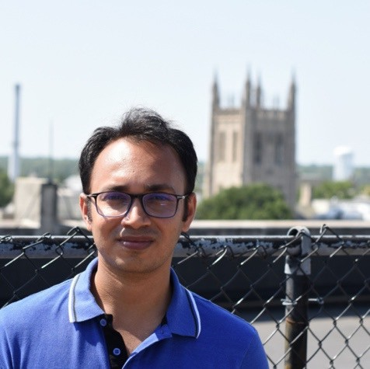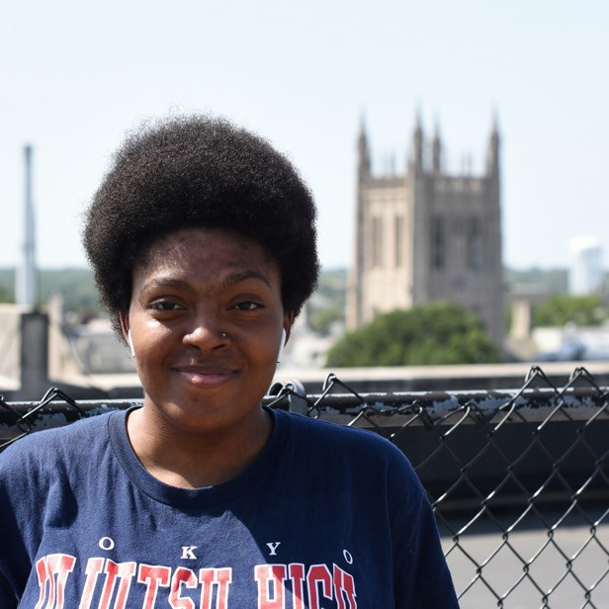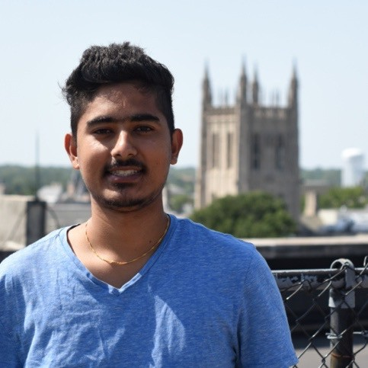

Abhijeet Abhi
Shakeila Davis
Manoj Gadtoula

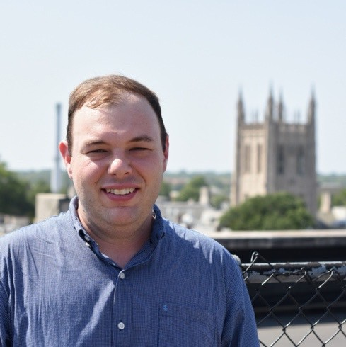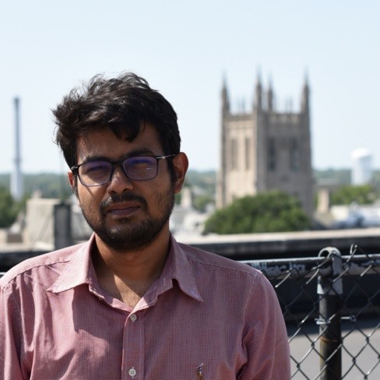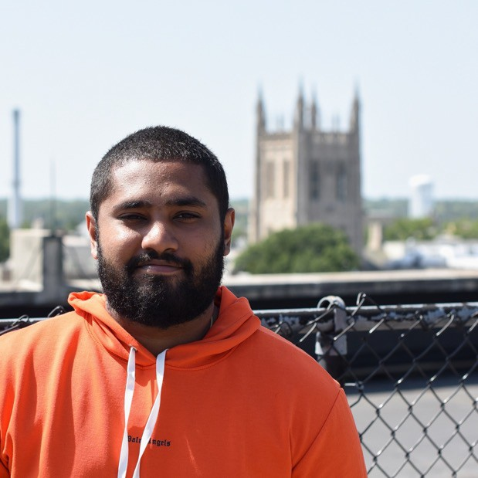

Brady Jones Hriday Joni
Risi Liyanage

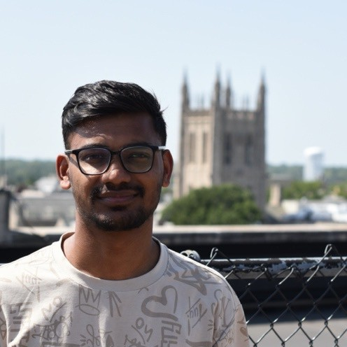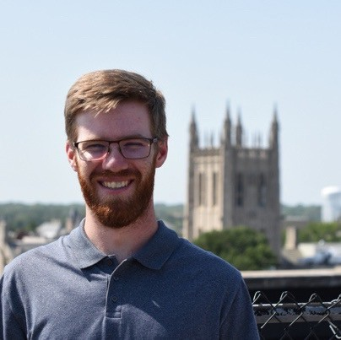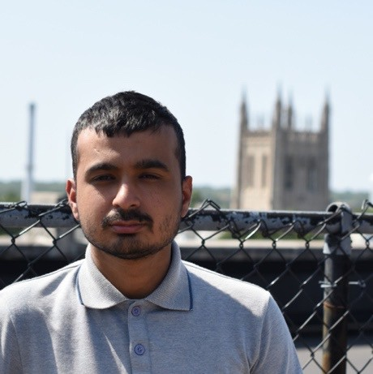

Avinash Sah
Marek Spader
Bibek Tiwari 12

Student News

PAGSA
We have had many exci.ng events in the past year! We had a costume contest for Halloween and many students showed up with some very interes.ng costumes.
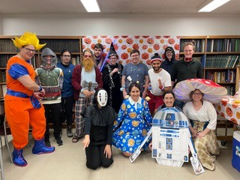
Our Thanksgiving Potluck was well a@ended by both graduate students and faculty and is a tradi.on we hope will con.nue for the future. We also had several other social events that included bowling, game nights, and beach volleyball during the summer. Our nine new graduate students were welcomed to the department at the annual Fall Picnic that was held at Stephens Lake where everyone enjoyed food, good company, and some

Halloween fun
shade from the blistering sun.

This year, we con.nued our programs in mentoring the newer graduate students and PhysAssist. These programs promote mental health awareness as well as easing the transi.on into grad school and everything that comes with it. In February and March, we had many students present their research at the BPS and APS mee.ngs respec.vely. During our monthly journal club mee.ngs, we had a good mix of scien.ﬁc and fun talks that ranged from spectral biclustering to the number density of chickens in the universe!
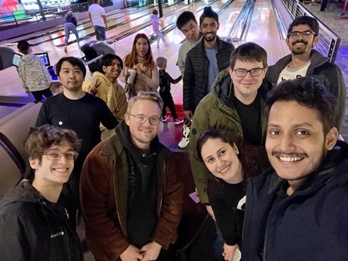
A new group was recently started in the department, Mizzou Women in Physics and Astronomy (MOWiPA). This group serves to
represent women and gender minori.es in the
department as well as to provide support and resources to these groups. MOWiPA is represented by all levels within the department, from undergraduates to faculty. We cannot wait to see what exci.ng news and opportuni.es this group will have for the future.
News contributed by Vicki Kuhn, PAGSA
president. Bowling Night

follow “Mizzou Physics and Astronomy Graduate Student Association” on Facebook

Society of Physics Students
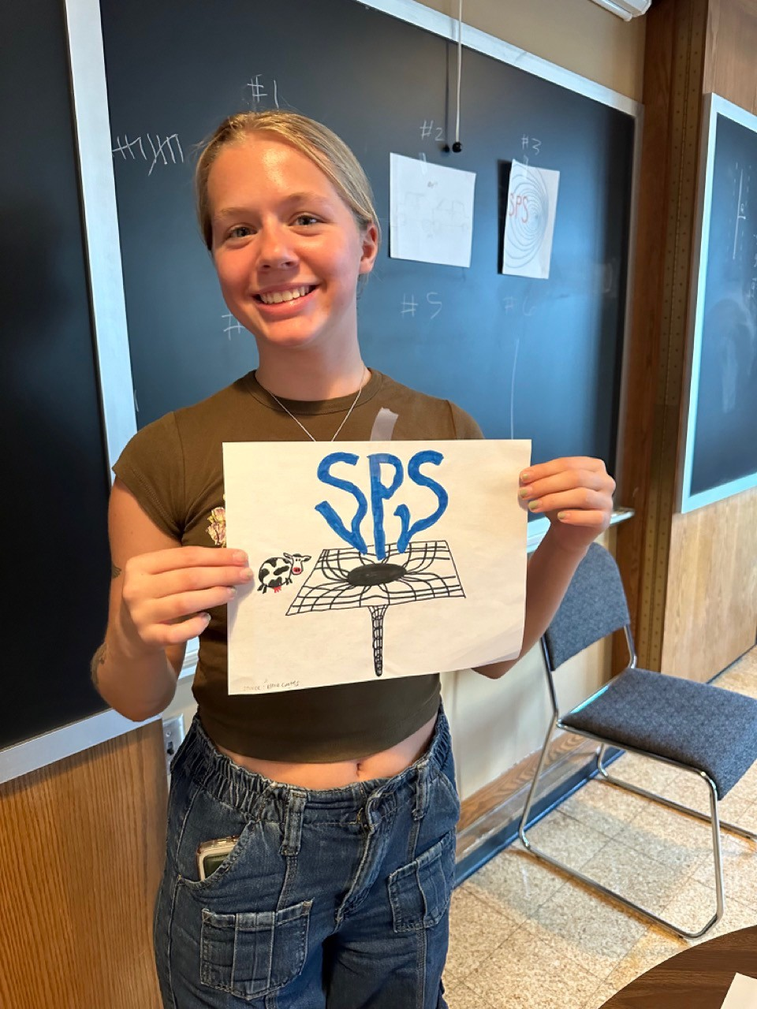
Society of Physics Students is a club that fosters growth in educamon, career, and social areas. We hold informamonal meemngs to help students prepare for applying to graduate school and REUs. We also talk about gerng involved in undergraduate research. We hold fun meemngs as well, like making liquid nitrogen and playing physics themed trivia.
These meemngs have been classic meemngs that we hold every year, both to keep students informed and to give students a place to make connecmons within their major.

Even with it being early in the year, SPS has done a lot already. We made our best batch of liquid nitrogen ice cream yet and had fun doing some liquid nitrogen demonstramons. New for this year, we designed t-shirts! Our winning design was drawn by Ellie Gates, SPS’ treasurer and a junior here in the physics department. For the future, we
have some presentamons about current events in physics, such as the recent Nobel Prize announcement, as well as

more fun trivia nights.

News contributed by SPS President Julianna Bayless
Ellie Gates (?) with the T-shirt Design

Scholarship Recogni;on
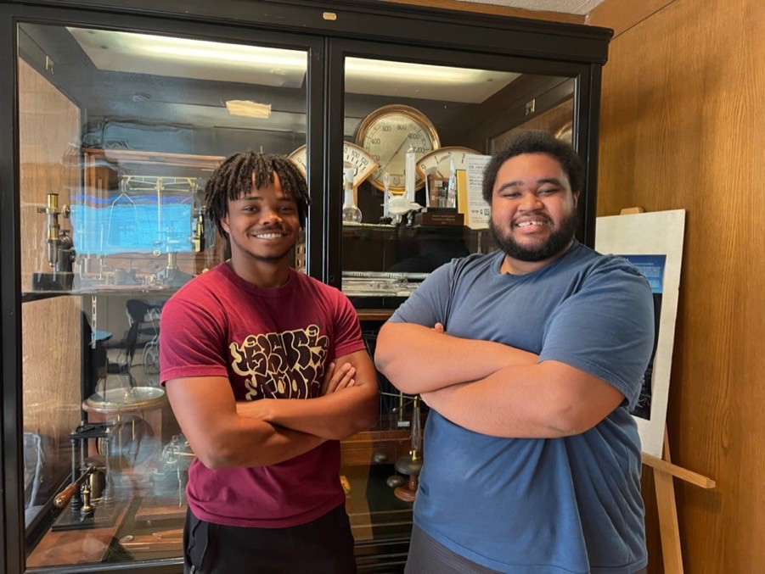
Donavan Flagg and Jayden Francois
By offering financial support to promising and high-achieving undergraduates, TEAM-UP Together encourages more young Black and African American students to follow their passion for science.
Students.

Two of our undergraduate students, Jayden Francois and Donovan Flagg, were awarded TEAM-UP Together Scholarships of $10,000 for the 2023-24 academic year. TEAM-UP Together is a partnership between the American Association of Physics Teachers, the American Astronomical Society, the American Institute of Physics, the American Physical Society, and the Society of Physics

MU Astronomy Club
Last school year we took our ﬁrst club trip to Black Mesa State Park, driving there over spring break. It is the closest Bortle class 1 locamon to Mizzou, The weather didn’t fully cooperate, but we smll had a great mme! The photo shows the 6 club members standing in Colorado, New Mexico, and Oklahoma at once. We hiked to the top of Black Mesa to watch the sun set and were able to see the Sierra Grande volcano from the top! Despite it being a bit cloudy, the stars were smll excepmonally bright. Last school year was also the ﬁrst mme our club has made t-shirts. Members of the club designed the art below for the t-shirts. This semester we’re going to make hoodies with a new design we will make during our second meemng on the 14th of September.
We’re conmnuing our tradimon of monthly stargazing nights in addimon to our regular meemngs. We meet in Eagle Bluﬀs Conservamon Area on dates around the new moons to chat, look at the stars, and somemmes take some beaumful images!
We hope to see many new faces this year!

News contributed by club president Patrick Hayden
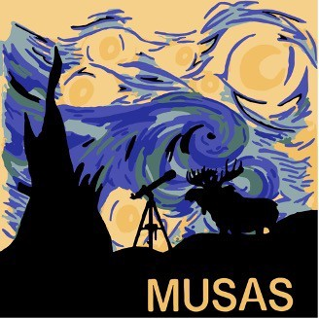
New T-Shirt Design
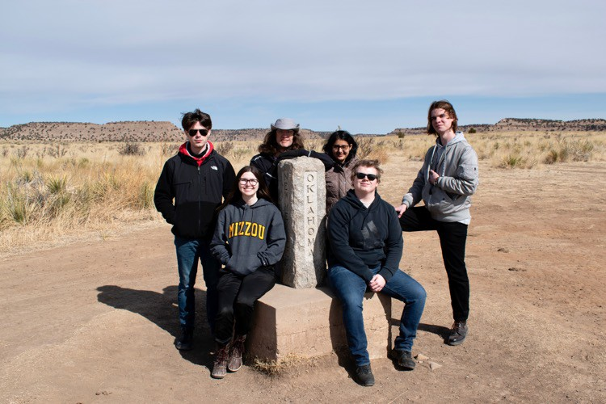
At tri-state Marker: Patrick Hayden, Gracye Allen, Steven Sco?, Vishvi Aurora, Max Sanson, and Vlad Sazhen
Laws Observatory Outreach

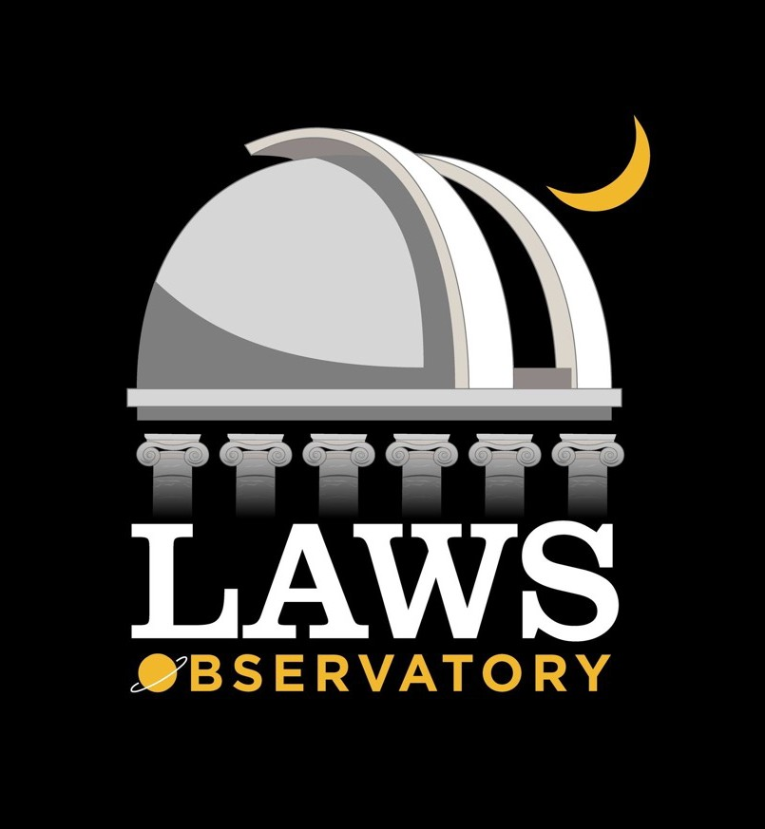
Laws Observatory on top of the Physics Building continues to be used for outreach and education on a weekly basis. Wednesday night viewing for the public is open (weather permitting) all year except during the coldest months. The events are run by student volunteers and by Valentine German and Randall Durk of the Central Missouri Astronomical Society. For news and information follow Laws Observatory on Facebook.
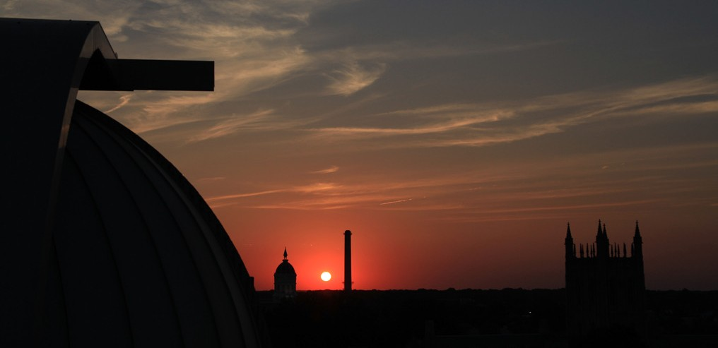
On behalf of the observatory, Haojing Yan received a number of donated items from Mr. Charles Lodwick of Columbia: two Celestron telescopes, one Meade Maksutov-Cassegrain telescope, one large Mead Binocular, and several accessories. These items will
be put to future use in the observatory.

There has been some improvement on the light pollution from the stadium, described on the This is described in the Laws webpage https://physics.missouri.edu/laws- observatory.

2022 Physics Leaders Mee;ng

This hybrid meeting was the first to include an in-person leaders meeting since the pre-Covid meeting in 2019. Chair Paul Miceli opened the meeting discussing the state of the department. Professor Miceli and Professor Bompadre discussed the graduate students and undergrads, respectively. Our students contributed to the discussion with Emma Burton talking about SPS activities and David Beckwitt summarized graduate student events over the past year.
Special presentations were given by Professor Deepak Singh, “MRSEC and collaborative projects” and Professor Gavin King, ”Towards an Ice Lithography Research Hub at MU”
New assistant professor Andrew Meng presented an overview of his research on “Switching Behavior of Epitaxial AlN and AlScN Thin Films on Si(111)”
During lunch a panel of the attending Physics Leaders met with students for an exchange of experience and advice.
A&S Dean Cooper Drury met with the faculty and leaders at the end of the day.
Our Friday evening dinner and awards presentation was held at Les Bourgeois Bistro in Roucheport.

Paul Miceli and John Shumway presented 2022 Physics Leader’s Awards for Outstanding Student Presentations to: Alex Daykin,
Dillon Balthorp,and Corey Valleroy

Faculty Recognition Awards were presented to: Shi-Jie Chen, Yicheng Guo, and Xiaoqin Zou

Paul Miceli with Ronald Boain and Catherine Rangel-Boain Presented the Boain Dissertation Awards for best doctoral dissertation to
First Place: Sicheng Zhang Second Place: Jimmy Ling, Alex Bretana
Paul Miceli presented Physics Distinguished Alumni Award to Dr. Bobby Guenther. Dr.
Guenther. Dr. Guenther was recognized for
exceptional career and legacy of scholarship in Optical Science and Photonics, leadership and vision for the next frontiers in optics, and mentorship and influence on other researchers in optical science.

Our student presentations on Friday afternoon provided a sampling of our student research:
Corey Valleroy (Advisor: Prof. Carlos Wexler)
“Molecular dynamics simulation study of sodium dodecyl sulphate on single walled carbon nanotubes in aqueous solution: surfactant coverage and water penetration ”
Alexander Daykin (Advisor: Prof. Paul Miceli)
“Disorder in Hydrogenated Graphene Revealed by X-ray and Neutron Scattering ”
Dillon Balthrop (Advisor: Prof. Maria Mills)
“Measuring the effects of C-terminal deletion in mycobacterial type IA topoisomerases using magnetic tweezers”
Ehsan Faridi (Advisor: Prof. Giovanni Vignale)
“Atomic-Scale Spin-Wave Polarizer Based on a Sharp Antiferromagnetic Domain Wall”
Charles Mentzer (Advisor: Prof. Aigen Li)
“Spatially Resolved PAH Emission in the Protoplanetary Disk around HD 97048 and HD 169142”

Shi-Jie Chen, John Shumway, Paul Miceli

Paul Miceli, Corey Valleroy, John Shumway
Alumni Award recipient Bobby Guenther and Paul Miceli

Re:rements
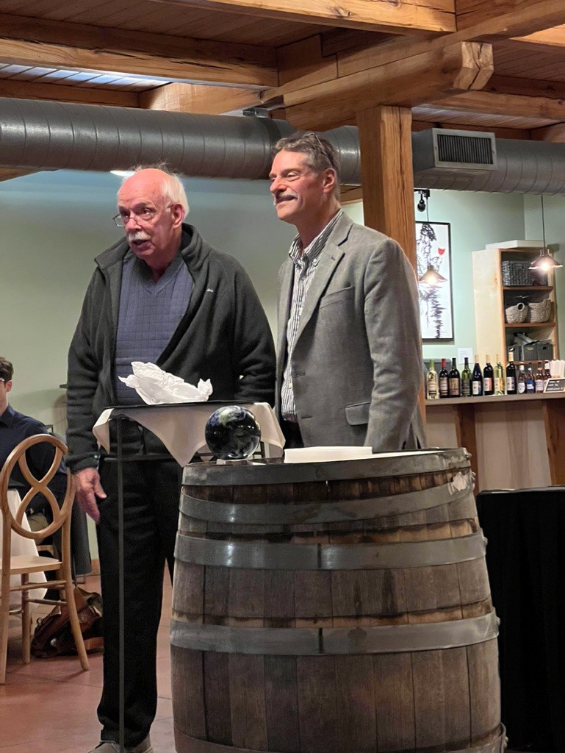
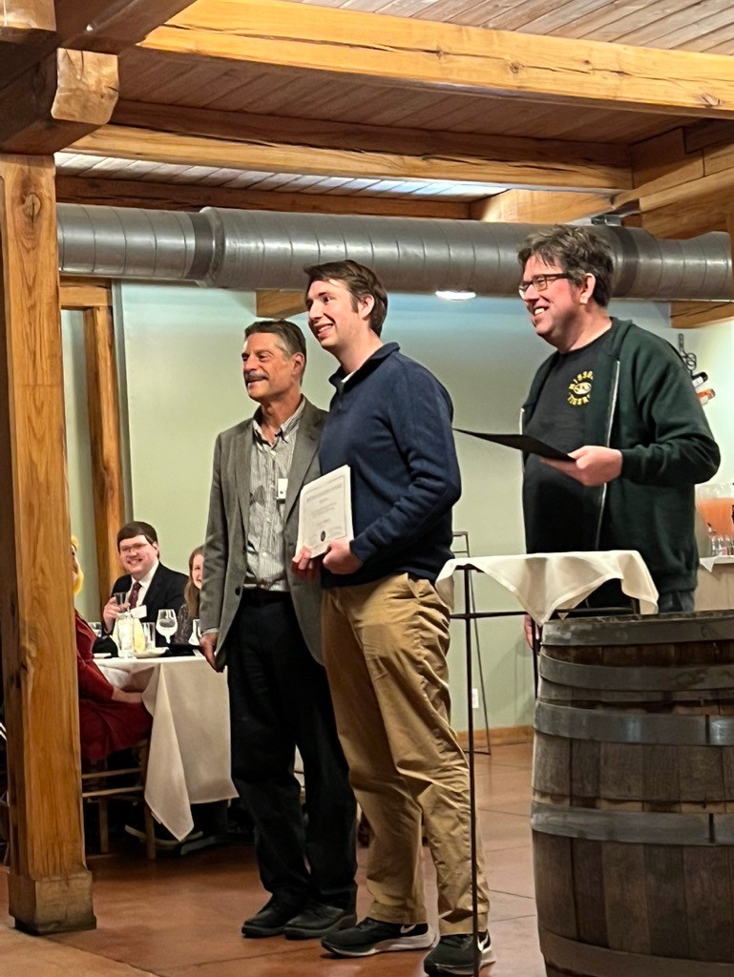
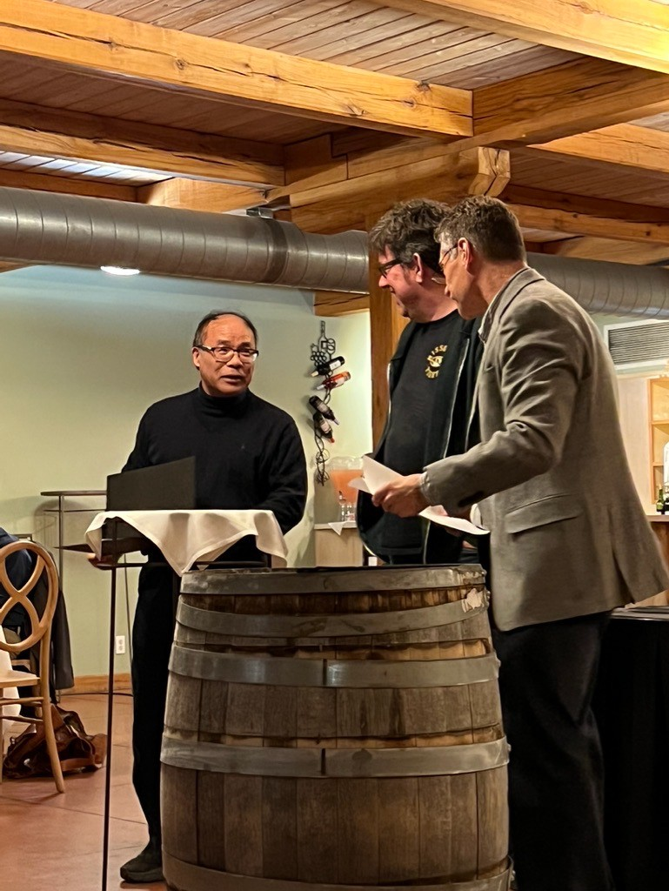
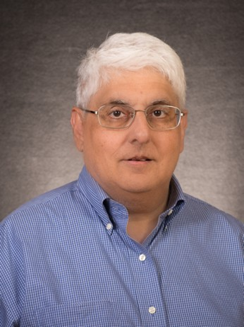
Prof. David Singh retired from our department in March 2023. David joined the department in 2015 from his previous position as a corporate fellow at Oak Ridge National Laboratory.
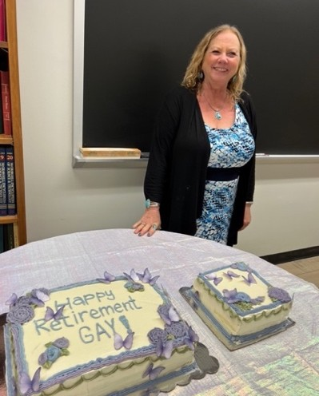
David is a theoretical physicist in condensed matter physics who during his time here was recognized as a Curators' Professor, a prestigious position bestowed to outstanding scholars with established reputations. He is a longtime Fellow of the American Physical Society (since 1997). Among other accomplishments, David co-authored Planewaves, Pseudopotentials and the LAPW Method and approximately 500 publications in scientific journals. The department appreciates his contributions in both research and teaching over the last eight years.

Gay Sturgeuss retired at the beginning of August after 20 years in our department office. Gay provided the continuity between the transitions in our department, working for five different department chairs over the years. Gay was recognized at her May 7 retirement party by chair Paul Miceli as the department problem solver and holder of institutional knowledge, knowing how to cut through the bureaucracy and who to contact to get things done. We thank her for the many things she has done for the department and hope she will enjoy her well-deserved retirement and spending more time with family.

In Memoriam

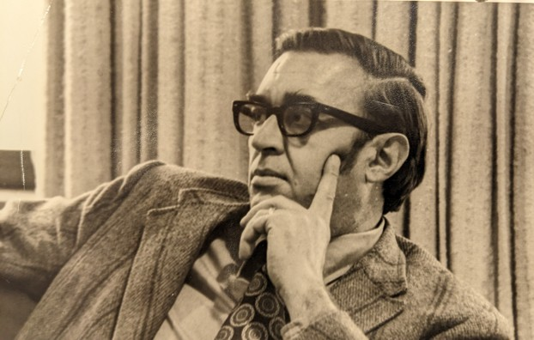
Many alumni will remember long 0me physics professor Dr. Cliﬀord Tompson who passed away January 22, 2023, at the age of 93.
Professor Tompson received his BA in Physics from the University of Missouri and leE to work for the Navy in California. He returned to MU for his graduate work, and aEer receiving his PhD in 1959 he joined the faculty of the Physics Department and served there un0l he re0red
as Professor in 1992. Cliﬀ served as Director of Undergraduate Studies in Physics for several years and had a deep commitment to undergraduate students. He received several awards for outstanding teaching and in 1988 received the Outstanding Alumnus Award from the College of Arts and Sciences. Following re0rement, he con0nued to teach his
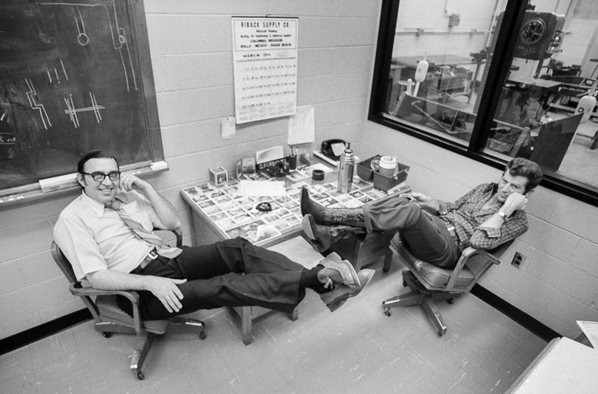
favorite courses for several more years. His research programs were primarily in studies of the proper0es and characteris0cs of condensed maSer using X-ray and neutron scaSering techniques.
Cliﬀ was named Emeritus Professor upon his re0rement and was greatly honored when his colleagues and friends established the Cliﬀord W. Tompson Scholarship in Physics. Many of our

1Professor Tompson hanging out with Cliﬀ Holmes in the physics shop in March of 1976. Photo by Errol Sandler.
undergraduate students have beneﬁSed from this fund.

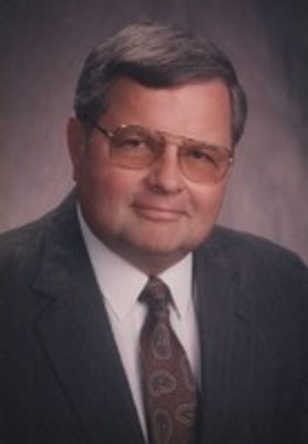
Many graduates will also remember Dr. Robert (Bob) Hurst, 85, who passed away on Sunday June 11, 2023, at the Lenoir Woods Assisted Living Center in Columbia. Hurst obtained his Bachelors, Masters, and Doctorate in Physics in 1964 from Penn State University. From there, Bob was hired as an Associate Professor of Physics at the University of Missouri – Columbia in 1964. He taught Physics and Computer Programming for over 20 years and performed research at UMC’s Nuclear Reactor. In 1974 he began consul0ng at Boone County Hospital as a medical physicist. He eventually re0red from Mizzou and worked full 0me for Boone Hospital. He worked with the Radia0on Therapy, Bio Med Department and Radiology Departments as well as being instrumental in Boone Hospital’s TeleMed Program. He re0red from
Boone in 2008 aEer managing the Radiology department for many years.

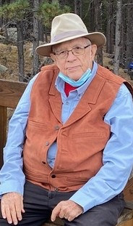
James D. Pa*erson, alumnus and former Physics Leader passed away October 22, 2020. He obtained a BA degree from MU, an MS degree from the U. of Chicago, and a Ph.D. from the U. of Kansas, all in physics. He was an pssistant professor at Idaho State University, an associate professor then professor at the South Dakota School of Mines and Technology, a professor then professor and department cead at the Florida InsKtute of Technology. In addiKon, he was a visiKng professor at the U. of Notre Dame, the U. of Nebraska, and the Federal University of Pernambuco in Recife, Brazil. He has has wriOen several papers and books, both technical and ﬁcKonal. His last book was (with Bernard C. Bailey), “Solid State Physics, An IntroducKon to the Theory,” Springer, Verlag, 2018.

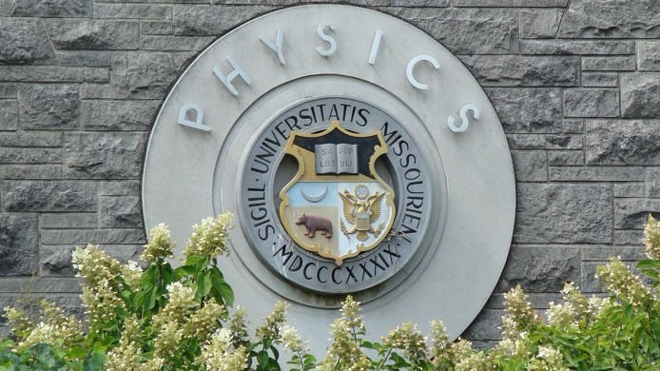

If you know a young high school student interested in a science career, there are many opmons with a degree in physics. Our website: hkps://physics.missouri.edu/undergrad/resources
To visit the department contact MU Office of Admissions
230 Jesse Hall
Columbia, MO 65211-1300
phone: 573-882-7786
fax: 573-882-7887
email: mu4u@missouri.edu


College of Arts and Science
Department of Physics and Astronomy University of Missouri
Communiqué is published annually by the Department of Physics and Astronomy at the University of Missouri.

Editorial Oﬃce
Department of Physics and Astronomy 223 Physics Building
Columbia, MO 65211
Phone: 573-882-3335
E-mail: umcasphysics@missouri.edu Web site: physics.missouri.edu

Editorial Board Linda Godwin Paul Miceli

The department appreciates hearing from alumni and friends. Send announcements or milestones to the address listed above.
223 Physics Building
Columbia, MO 65211



Check us out on Facebook: hXps://www.facebook.com/MUphysics
Update your contact information, through the MU Alumni Association website: website: http://www.mizzou.com/.
You do not need to be a member to update your information.

Do you know a department alumnus that you want to nominate for a Department of Physics & Astronomy Distinguished Alumni Award? Visit this website for more information:
https://physics.missouri.edu/alumni-and-giving

We welcome career profiles of our alumni - email us
at umcasphysics@missouri.edu with your story and we will include it on our webpage.

Department news: hXps://physics.missouri.edu/news
If you didn’t also receive this newsletter via email , please update your email address at http://www.mizzou.com (Alumni Office)

